CAPSTONE PROJECT  
  
OLYMPIC SPORTS ANALYSIS

**Introduction:**  
The Olympic Games represent the pinnacle of athletic competition, drawing global attention and showcasing the talents of athletes from around the world. Analyzing data from the Olympic Games provides invaluable insights into trends, performance metrics, and the dynamics of various sports. This capstone project aims to harness the power of SQL and Power BI to delve into the world of Olympic sports, uncovering patterns, identifying factors influencing success, and generating actionable insights.

By leveraging SQL, we will query and manipulate vast datasets encompassing historical Olympic data, including athlete profiles, event results, and medal standings. Through intricate data analysis techniques, we will unravel trends spanning multiple Olympic editions.

The integration of Power BI will enable us to visualize our findings in an interactive and intuitive manner, fostering comprehension and facilitating decision-making This project will employ problem-solving methodologies to extract meaningful conclusions from complex datasets.

Ultimately, this analysis aims to provide stakeholders in the sporting world, including athletes, coaches, and policymakers, with valuable insights to inform strategies, enhance performance, and foster the spirit of competition in Olympic sports.

This capstone project delves into Olympic sports analysis using SQL and Power BI. By leveraging these tools, we aim to uncover trends, performance metrics, and influential factors within the realm of Olympic sports. The project seeks to provide actionable insights to enhance strategies and performance in the sporting world.

Top of Form

**Objectives:**

### This capstone project aims to analyze Olympic sports data using SQL and Power BI to uncover trends, performance metrics, and influential factors. By employing problem-solving methodologies, it seeks to provide actionable insights for stakeholders in the sporting world to enhance strategies, performance, and the Olympic experience. Tools Used:

* SQL Server Management Studio (SSMS) for database management and querying.
* Power BI Desktop for data visualization and dashboard creation.

**Process:**

* Extract and load Olympic sports data into a SQL database.
* Cleanse and preprocess the data to ensure accuracy and consistency.
* Perform in-depth analysis to identify trends, patterns, and insights.
* Develop interactive dashboards using Power BI for visualization. Provide comprehensive documentation detailing the project methodology and findings.

By employing problem-solving methodologies, it seeks to provide actionable insights for stakeholders in the sporting world to enhance strategies, performance, and the Olympic experience.

**MECE:**  
To structure our capstone project on Olympic sports analysis using the MECE (Mutually Exclusive, Collectively Exhaustive) framework, we can organize it into distinct categories that cover all aspects of the analysis without any overlap.

1. Data Collection and Preprocessing
2. SQL Analysis
3. Power BI Visualization
4. Problem-Solving Approaches
5. Future Directions

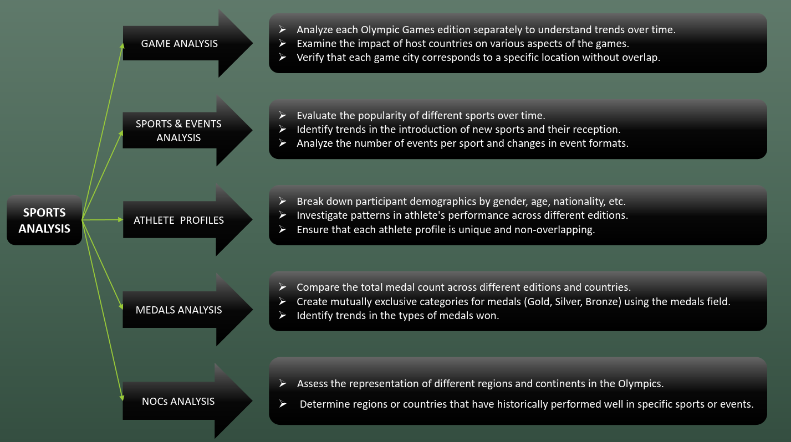

By organizing our capstone project according to these MECE categories, I ensure that each aspect of the analysis is distinct yet collectively covers all relevant aspects of Olympic sports analysis. This structured approach will help to present all findings in a clear and comprehensive manner, facilitating understanding and decision-making for target audience.

**Documentation of the Project:**

* **Data Acquisition:** The data was provided in SQL format. Initially, the CSV files were uploaded into a SQL database, and data extraction was performed based on specific queries. Additionally, The project involved receiving data in CSV format, each category separated into different files such as city, competitor_event, event, games, games city, games_compatitor, medal noc_region, person, person_region, and sport.
* **Data cleaning:** In SQL it involves identifying and handling missing values, removing duplicates, standardizing formats, handling outliers, validating constraints, transforming data, and ensuring consistency. Techniques include using functions like TRIM, and REPLACE, along with SQL statements like DELETE and UPDATE to improve data quality and reliability for analysis.
* **Excel Visualization:** After uploading the data into the SQL database, it was exported to Excel. Visualizations were then created in Excel based on the extracted data.
* **Integration with Power BI:** Furthermore, the SQL database was connected to Power BI. Data transformation was carried out according to specific queries, and key performance indicators (KPIs) and metrics were computed. An overview of the visuals was provided to efficiently extract insights from the data.

**POWER BI VISUALIZATION:**  
To load data into Power BI, these are the following steps:

* Launch the Power BI Desktop application on your computer.
* In the Home tab of the Power BI Desktop, click on the "Get Data" button located in the "Home" ribbon.
* A window will pop up with various data source options. Select the appropriate data source for your project. Common options include Excel, CSV, SQL Server, Web, etc. As our data is in CSV format we choose csv and then click on "Connect."
* Once selected the desired data, click on the "Load" button or the "Transform Data" button if we want to perform data transformations before loading. Power BI will then load the selected data into the data model.
* The loaded data will be displayed in the "Fields" pane on the right side of the Power BI window.

* **Modal View For Olympic Sports Analysis (ER Diagram):**

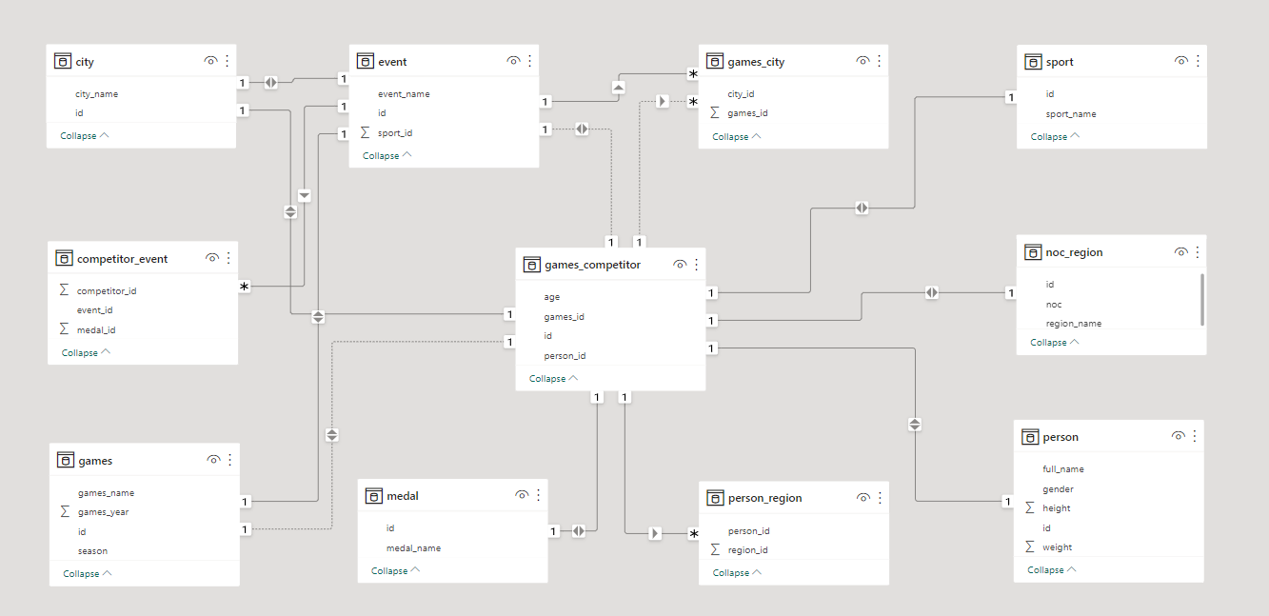

This documentation outlines the process of importing data from CSV files to SQL, creating Excel visuals, connecting the SQL database to Power BI, and deriving insights through visualization and data analysis.

**Conclusion:**

The Capstone Project on Olympic Sports Analysis demonstrates the application of SQL and Power BI in extracting, analyzing, and visualizing complex sports data. By uncovering insights and trends, this project provides valuable information for stakeholders and enthusiasts, contributing to a deeper understanding of Olympic sports dynamics.

This documentation serves as a comprehensive guide to the Olympic Sports Analysis Capstone Project, detailing the methodology, findings, and potential avenues for future exploration.

____________________